Cleveland Common UI Application Installation Guide

Mohammad Aldeeb

ELREHA

This document is a modified version of *“NXP Manufacturing Tool V2 Quick Start Guide”*

|  |  |  |  |
| --- | --- | --- | --- |
| Version | Author(s) | Description | Date |
| 0.1 | Mohammad Al-Deeb | Initial Draft | 09/19/2023 |
| 0.2 | Yazan Hamadeh | Edit | 11/30/2023 |
| 0.3 | Yazan Hamadeh | Edit | 04/05/2024 |
| 0.4 | Dina Jabay | Edit | 04/08/2024 |

Contents

1. Overview2

2. Tools2

3. Production Image Flashing2

4. Deploy UI Application6

Figures

Figure 1- Set Boot Mode3

Figure 2- HID Device3

Figure 3- MFG Tool detects UI4

Figure 4- Flashing Progress4

Figure 5- Process Continue5

Figure 6 - Terminal Feedback5

Figure 7 - Stop Process6

Figure 8 - Debug port connection7

# Overview

In order to enable the QT application to run, this paper provides a step-by-step tutorial on how to use Manufacturing (MFG) tool V2 (Provided by SDK DVT1.0.5-2023-04-29.zip, inside folder Welbilt-mfgtools-productionImage) to update the UI operating system to the production image.

Please note that steps 4 and 5 are only necessary for the UI application's development and debugging; once it's ready for production, the Application may be added straight to the Production image.

*Note:*

The UI is supplied with a running image, but it won’t accept the username root and the password provided based on the serial number.

# Tools

* USB Cable, Type A to Type A

Required to transfer production image to the UI.

* USB to 232TTL converter (optional)

Used to monitor update process.

# Production Image Flashing

* 1. Set Boot Mode

Set the correct boot mode and connect the OTG port to the PC on which the MFG Tool application will be run.

To set the correct boot mode, refer to figure 1 below

After connecting to PC with the correct boot mode setting, a HID-compliant device will be shown in the Device Manager as shown figure 2 below:

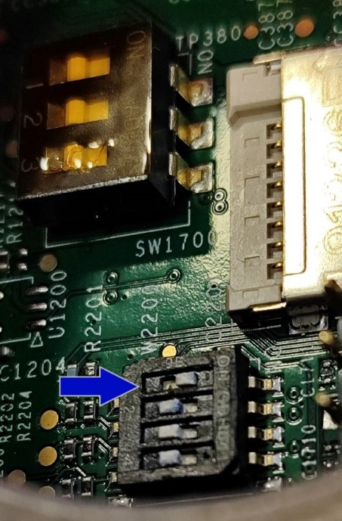

Figure 1- Set Boot Mode

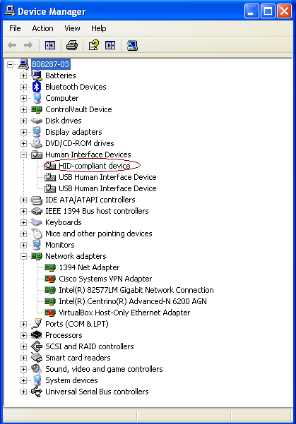

Figure 2- HID Device

* 1. **Run MFG tool**

Double click the application to run.

There is a limitation that, when using the MFGTool V2 for the first time to burn an image to a device (such as: i.MX 6Quad ARM2, i.MX 6DualLite Sabre-SD, and so on), the device must be connected to PC before MFGTool V2 starts running.

Only two buttons can be clicked, Start/Stop, and Exit.

Start/Stop is used to start/stop the burning process. If you re-start the burning process after you stop it, the process will try to continue from the point where you stopped before, but it is not guaranteed that it can continue successfully. It is NOT recommended to do this.

Exit is used to exit this application. Please note that you can exit the application only after you stop the burning process.

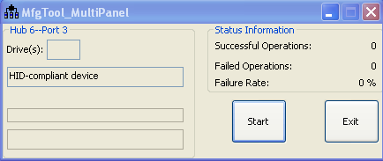

Figure 3- MFG Tool detects UI

* 1. **Start Flashing**

Click “Start” button. If you have a terminal tool to monitor the debug serial port of your board, it is suggested to open it. You can get more information from it.

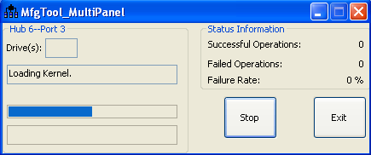

Figure 4- Flashing Progress

Process continuing:

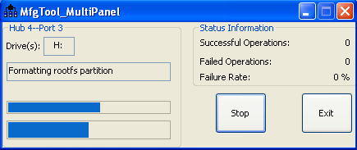

Figure 5- Process Continue

**You can find information from the terminal.**

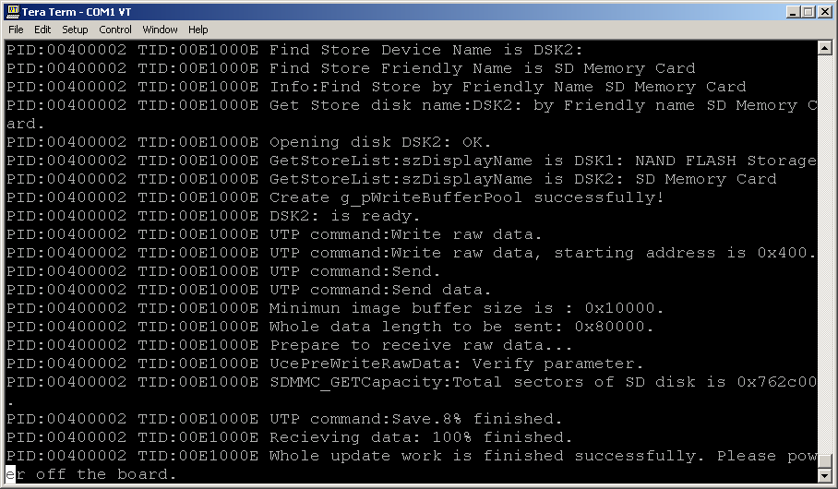

Figure 6 - Terminal Feedback

It is done. Click **“Stop” to finish, and Click “Exit” to terminate the application.**

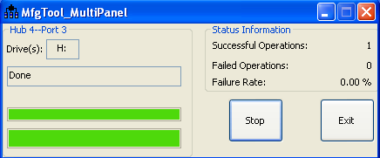

Figure 7 - Stop Process

# Deploy UI Application

* 1. **Setup UI pins**

As shown in the image below, a connection must be made via the UI's debug port to monitor the UI.

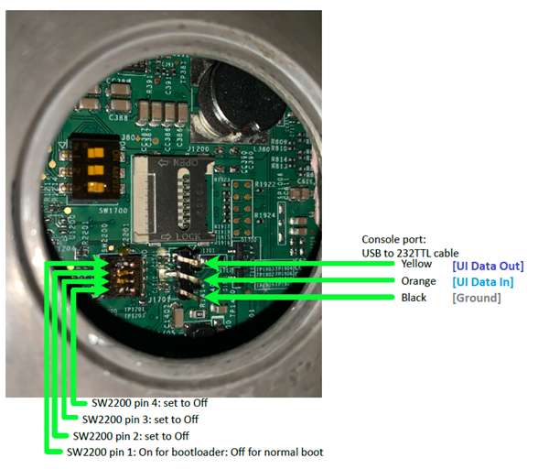

Figure 8 - Debug port connection

* 1. **Update the new package**

To install a new package using USB sick:

* + Copy the package file (.tar) to a new directory in the USB (welbilt/package/cleveland-update-1.tar)
  + Insert the USB and wait for around 1~3 min then restart the UI.
  1. **Setup dip switch pins**

For dip switch SW1700 pin one should be on as shown in the image.

